Case

History

A 45–year-old woman was referred because of swelling of the abdomen for 4 months. In a health centre she was diagnosed of having ascites presumed to be caused by liver disease. She was treated with furosemide, but without satisfactory response. She was from a village near Mangochi at Lake Malawi.

Her previous medical history was unremarkable; she did not recall any episodes of jaundice; she never used alcohol. Her HIV status was unknown.

Physical examination

She was moderately ill, with blood pressure of 90/60; pulse rate 100/min, regular; respiratory rate 18/min and temperature 37.1 0C. There were no leukonychia, no Dupuytren’s contracture, and no palmar erythema.

The JVP was not raised.

Head and neck: pale conjunctiva, not jaundiced; in the mouth no oral thrush or Kaposi’s sarcoma. There was no lymphadenopathy.

Lungs: bilateral dullness and reduced breath sounds. The heart was normal.

Abdomen: on inspection massive distension; there were no distended veins or caput Medusae. On percussion there was dullness all over. On palpation there was a fluid thrill; no organs could be palpated.

Extremities: There was bilateral pitting oedema in both legs up to the inguinal area.

Investigations

Hb 6 g/dL

MCV 65 fL

Total white count 4 x 109/L

Platelets 180 x 1012/L

Urine dipstick: normal

HIV test negative.

Figure: massive abdominal distension

Questions

1. What is the differential diagnosis?
2. What investigations would be useful?
3. What is the most likely cause in this patient?
4. What is the management?

Answers

1. This patient has massive ascites that caused marked abdominal distension pushing up the diaphragm. This explains the chest signs as the lungs cannot expand adequately on inspiration.The most important differential diagnoses of massive ascites in Malawi include tuberculous ascites, ascites complicating liver disease, malignant ascites (caused by peritoneal metastases), renal disease or cardiac failure. The physical examination does not give clues for cardiac failure or liver cirrhosis; in renal disease you would expect urine abnormalities and more generalized oedema. Although tuberculous ascites may occur in HIV negative patients, it is much more common in HIV infected individuals. It is useful to look for tuberculosis in other places such as the lungs or lymph nodes. Most patients will also have fever, weight loss and night sweats.

She has microcytic anemia that may suggest iron deficiency possibly due to chronic blood loss in the gastrointestinal tract; this should be taken into account in the work-up to a final diagnosis.

1. An ascitic tap and an ultrasound examination are very helpful to make a presumptive diagnosis and these procedures should be available in all hospitals in Malawi.

In this case the ascitic tap showed straw coloured fluid, with a total white cell count of 5 x 109/L; no red blood cells and protein 0.5 mg/dL. This is compatible with a transudate which may be found in ascites caused by liver disease or cardiac failure. In tuberculous ascites or malignant ascites higher protein levels are expected and the ascites would then be called an exudate; more white cells would also be expected. An ultrasound of the abdomen showed a dilated and calcified portal vein, periportal fibrosis and a hyperechogenic liver texture (Figure 2). There was marked splenomegaly and massive ascites.

1. As cardiac, renal and liver disease and tuberculosis are unlikely, the findings suggest periportal liver fibrosis with portal hypertension caused by schistosomiasis.
2. The schistosomiasis is treated with praziquantel. The ascites should be controlled with diuretics. Iron supplementation should be given.

Discussion

Schistosomiasis is endemic in Malawi in particular around Lake Malawi. *S. haematobium* infection is most common and leads to hematuria, bladder polyps and over time to hydronephrosis and renal failure. Patients are at risk to develop bladder carcinoma.

*S. mansoni* infection is more focally distributed in Malawi and causes colonic polyps and periportal fibrosis leading to portal hypertension with ascites, splenomegaly and oesophageal varices; the latter may cause fatal bleeding. If possible a gastroscopy should be done; if oesophageal varices are found, these should be ablated with a sclerosing agent such as alcohol. However, this will not be possible in most hospitals in Malawi. The microcytic anemia in this case suggests chronic blood loss in the gastrointestinal tract possibly caused by oesophageal varices or colonic polyps leading to iron deficiency.

Causal treatment for schistosomiasis with praziquantel should be given as damage caused by schistosomiasis may to a large extent be reversible. In this case the portal hypertension may well be fixed and irreversible; the hyperechogenic appearance of the live suggests that she may have advanced liver fibrosis. In this case diuretics were not effective although it was not clear whether she received adequate doses. In patients with massive ascites, drainage of the ascitic fluid may be tried after which diuretics (furosemide and spironolactone) may work better and these should be titrated to optimal dosage.

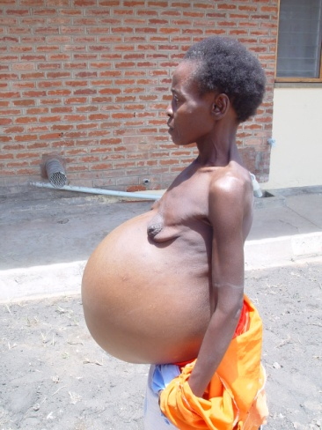

Figure 1. Massive distension of the abdomen

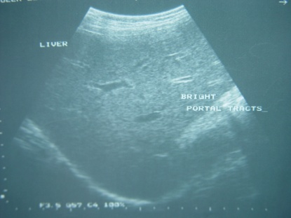

Figure 2. Ultrasound showing bright portal tracts caused by fibrosis around schistosomal eggs.