**The Revised curriculum for the training of the Doctor of Global Health and Tropical Medicine**

The Registration Committee Medical Specialists (RGS: Registratie Geneeskundig Specialisten) recommended to make the training program more practical and to better outline the two programs – classical program and mother and child care.

The OIGT falls under the responsibility of the Netherlands Society of International health and Tropical Medicine that delegated this task to the Concilium International Health and Tropical Medicine (CIGT).

While the OIGT is responsible for the organization and daily running of the training program, the CIGT oversees the quality of the training program by evaluating local hospital training programs, providing guidance on visitations for re-accreditation and by regular meetings with heads of training programs.

Introduction

While in the old version the CanMEDS ("Canadian Medical Education Directives for Specialists"). criteria were followed, it was felt that these mainly applied to medical doctors.

**Figure 1. Organogram**

**Training Institute International Health and Tropical Medicine (OIGT)**

**Concilium International Health and Tropical Medicine (CIGT)**

**Tasks**

* **Recruitment of AIGT**
* **Placement**
* **Evaluation**
* **Graduation**

**Tasks**

* **Supervision**
* **Quality control**
* **Visitation**
* **Biannual meeting and consultation with trainers**

**Foundation Training Institute International Health and Tropical Medicine (SOIGT)**

**Academic council**

**Registration Committee Medical Specialists (RGS)**

**Netherlands Society for Tropical Medicine and International Health (NVTG)**

**General assembly**

Box: The seven CanMEDS competencies

* **Medical Expert**
* **Communicator**
* **Collaborator**
* **Manager**
* **Health Advocate**
* **Scholar**
* **Professional**

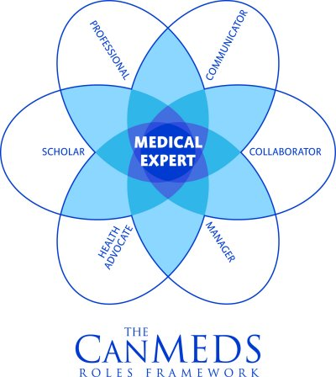

It was felt that the special character of the AIGT should be emphasized as it is a unique hybrid of curative medicine and preventive medicine, and in both areas the AIGT should develop leadership (see figure). In the new curriculum these are now called areas of expertise.

Figure 1. The AIGT curriculum - three areas of expertise

Each area of expertise starts with a general description, followed by a description of specific CanMEDS competencies in a general and in an international context.

In the old version the actual description of the field was captured in themes that elaborated extensively on all aspects of the field and were subdivided by the CanMEDS criteria. While the result was very complete, some overlap could not be avoided. In an attempt to produce fewer, more simple themes that were in the first place trainable, 8 themes were identified (see table). In addition, each of these themes required one or two activities or test moments that would assess whether the candidate had mastered the skill outlined in the theme and could be entrusted to perform the skill unsupervised. These are called EPAs – entrusted professional activities (table)

|  |  |
| --- | --- |
| **Theme** | **EPA** |
| A. Generalist in (Global Health) patient care | 1. Managing the adolescent and adult patient in a local context  2. Delivery of chronic care |
| B. Essential surgery | 3. Performing triage  4. Carrying out essential surgery |
| C. Mother and Child care | 5. Carrying out maternal and neonatal care  6. Managing the sick child |
| D. Epidemiology and Burden of Disease | 7. Apply knowledge of (international) epidemiology including Burden of Disease |
| E. Prevention | 8. Ability to administer preventive care in a global health context |
| F. Organisation of integral health care | 9. Organising health care |
| G. Medical management | 10. Performing medical management and leading an organisation |
| H. Policy making | 12. Promoting development of health care in medium and long term health care  13. Ability to promote and defend policy |